Interface ID: OL-8/OL-9
Created by: Mark Lund
Created Date: 9-26-2005

Description of Design Concept:
The vsdVFSImmediateUpdate process is a new Windows Service that accepts VFS update requests from various other processes via MSMQ queues and calls the appropriate dolVFSService web service to update the migrated Unisys record. The various feeding processes place messages in a “VFSUpdate” MSMQ queue. The vsdVFSImmediateUpdate service reads the message from the “VFSUpdate” queue, makes the appropriate web service call(s) and updates the Field System database with the status.

The service reads it’s app.config file at start up to obtain its database connection string key. It then connects to the vsdVFSImmediateUpdate database and obtains its basic operating parameters from the utAppConfig table. It also obtains its queue list, the Tran Type list, and the response code list from the utQueueList, buTranType, and buResponseValue tables (respectively) at startup. The service caches these tables in memory to minimize database access requests. Therefore, the service must be stopped/restarted in order for configuration changes to take effect.

A separate thread is spawned for each queue message processed. The queue message contains a Tran Type and record key. Based on the cached Tran Type table values, the service will pass the key to a stored proc. in the Field System database. The stored proc. returns a result set which the service turns into a string buffer. Also based on the cached Tran Type table, the service will pass the buffer to a web service. Upon receipt of the response, the service updates the Field System record. If an error occurs, the message is either returned to the queue for subsequent processing later or written to an exception table. The service logic and/or the web service response code will determine which action to take when an error occurs.

Performance:
Transaction processing time is affected by network conditions but a duration of < 250ms per transaction is expected, and the process should be able to process well over 100,000 transactions within any 8 hour period.

Test #1 – 5 threads ~ 238ms/trans. or 15,126/hr
~ 121,000 extrapolated for an 8 hour day.
~ 151,260 extrapolated for a 10 hour day.
~ 181,512 extrapolated for a 12 hour day.
~ 363,025 extrapolated for a 24 hour period.

Test #2 – 5 threads. 1 min. Timed test – 380 transactions per min.
Extrapolated to 22,800 transactions per hour
Extrapolated to ~ 182400 for an 8 hour day
Extrapolated to ~ 228000 for an 10 hour day
Extrapolated to ~ 273600 for an 12 hour day
Extrapolated to ~ 547200 for an 24 hour period

Decomposition/Flow Diagram:
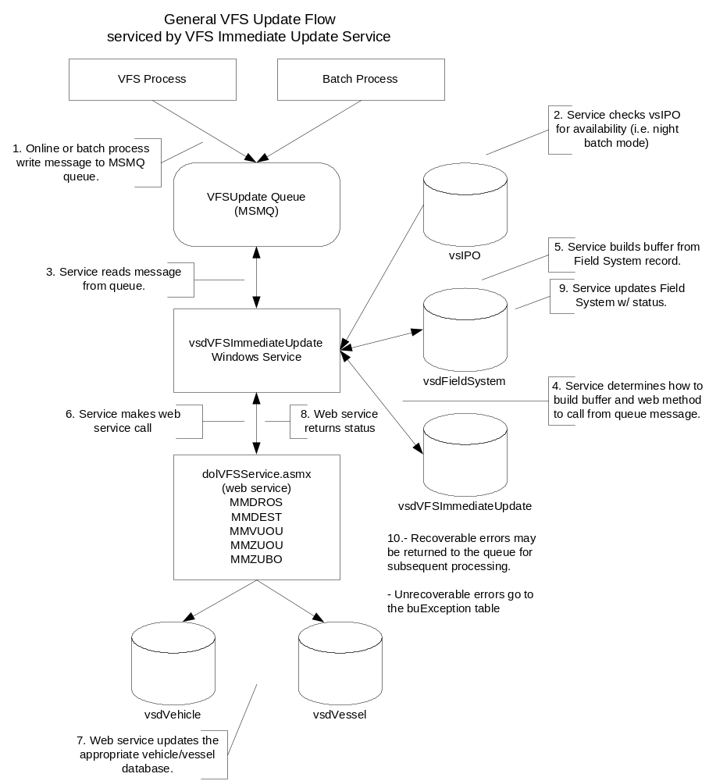

Functional Specifications:

Functionality:

- Online and batch jobs write messages asynchronously to the VFSUpdate queue. Messages consist of the TranType and record key.
- The service detects processor availability from the vsIPO database. If in night batch mode, the service’s main thread sleeps.
- When not in night batch mode, the service reads the message(s) in the queue and spawns a new thread to process the message.
- Using parameters in the vsdVFSImmediateUpdate table, the service is able to determine where to locate the field system record and which web service needs to be called based on the Tran Type of the queue message.
- The service calls a stored procedure in the vsdFieldSystem database to build the request for the web service by passing in the key. The stored proc. returns a result set that is converted to a string buffer.
- The UAR web service is called, passing in the buffer.
- The UAR web service updates the UAR vehicle/vessel database.
- The web service returns a status indicating success or failure.
- If the status is successful, the service updates the vsdFieldSystem record.
- If the status returned by the web service is not successful, or if the service is unable to communicate with the web service, the message is either returned to the queue for subsequent reprocessing or logged to an exception table in the vsdVFSImmediateUpdate database to be handled by the batch job vsdMSMQErrorLoadUtility. Errors are deemed recoverable or non-recoverable by the return code of the web service response. The buResponseCode table contains the response codes.

Appendix A: Database Tables
Table: utAppConfig: the table would be used to define application processing and configuration parameters.
Attribute Name | Type | Length | Description
Process | Varchar | 50 | The name of the process a set of parameters is for.
Name | Varchar | 50 | The name of a parameter the calling process is interested. Process & Name create a unique parameter.
Value | Varchar | 255 | The parameter value
Comment | Varchar | 255 | Description of the parameter and how it is utilized.

Table: buTranType: this table defines the transaction types and associated processing details.
Attribute Name | Type | Length | Description
Process | Varchar | 50 | The name of the process a set of parameters is for.
TranType | Varchar | 8 | The transaction type of the record written to the queue..
URL | Varchar | 255 | URL of the web service to be called.
Method | Varchar | 50 | Web service method to be executed.
KeyOffset | Smallint | 2 | The starting position of the VFS record key within the queue record.
KeyLength | Tinyint | 1 | The length of the key value to be extracted from the queue record
ConnectStringKey | Varchar | 50 | Connection key to the vsdFieldSystem database for server availability
SPSelName | Varchar | 50 | Database select stored procedure name.
SPUpdName | Varchar | 50 | Database update stored procedure name.
SPKeyParaName | Varchar | 50 | The name of the key used by the select and update stored procedures.
SPUpdParaName | Varchar | 50 | The name of the attribute that will be updated by the update stored procedure
ProcessingOrder | Tinyint | 1 | Defines the processing order when a transaction type requires more than process call.
ResponseOffset | Tinyint | 1 | The starting position of the Response Code within the return buffer
ResponseLength | Tinyint | 1 | The length of the Response Code value.

Table: buResponseValue: defines the processing response associated with a Response Code value to accommodate a many to one relationship between the Response Codes and their associated processing response. For example OU00, RS00 and DV00 all indicate a successful update and trigger the processing of the next record in the queue.
Attribute Name | Type | Length | Description
Process | Varchar | 50 | The name of the process a set of parameters is for.
ResponseCode | Varchar | 4 | The status code returned by the web service/method call
ResponseValue | Tinyint | 1 | Processing response code associated with the one or many response codes.  0 = success / process next record  1= recoverable error / retry  2 = non-recoverable error / send email and write to  exception table  3 = recoverable error / send email and retry

Table: utQueueList: identifies the server and name of the queue to be processed.
Attribute Name | Type | Length | Description
Process | Varchar | 50 | The name of the process a set of parameters is for.
Server | Varchar | 200 | The name of the server the queue will reside on
Queue | Varchar | 100 | The name of the queue to be processed.

Table: buException: processing error exception table.
Attribute Name | Type | Length | Description
ExceptionId | Int | 4 | Unique record identifier
Process | Varchar | 50 | The name of the process writing the exception
Message | Varchar | 2000 | The message that was read from the msmq queue. May have the processing status of the message concatenated to the end.
Source | Varchar | 50 | Identifies the source of the error, i.e. the method that was called.
ErrResponseCode | Char | 2 | Error categorization:  01 – recoverable error  02 – non-recoverable error  03 – recoverable error, NMVTIS brand update problem.
ErrDesc | Varchar | 5000 | All available information concerning an error. I.e. the buffer passed to a web service/method and the Response Code and error details that were returned.
ExceptionDateTime | Datetime | 8 | Date and time the exception occurred

